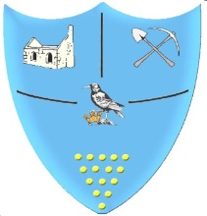 | Year 1- Summer 2- Homework Grid  Would you rather visit the Victorian seaside or the seaside today?
 | Geography/History | Art/DT | Science/Maths/ICT | R.E. / P.S.H.E/ PE
Past  Revisit | Draw a map of the world. Label the North Pole, South Pole and Equator. | Draw or paint a portrait of someone, in the style of Picasso. | Find all the doubles to double 10. Draw pictures to show the doubles. | Who is Richard Trevithick and why is he a significant person?
Present Consolidate | Draw a timeline of your life so far and include something you would like to do in the future. | Make a collage of the beach. | Draw pictures to show the order of your day. What do you do in the morning, afternoon and evening? What time do you go to bed? | Read ‘The Very Hungry Caterpillar’. Draw a diagram of the life cycle of a butterfly.
Future  Ignite | Research the country Egypt. Which continent is it part of?  Can you draw the flag? | Design and make a free-standing structure. | Draw a picture of a pet of your choice. Write a list of all the things you need to do to take care of them. | Practise balancing on your left and right leg. How many different shapes can you make?
Bring your homework in to show in class or send a picture on eschools.
Try to do at least one task each week.
Don’t forget to also read at home.

