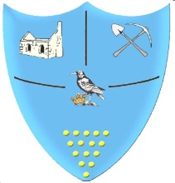 | Year 1- Spring 2- Homework Grid
 | Geography/History | Art/DT/Music | Science/Maths/ICT | R.E. / P.S.H.E/ PE
Past  Revisit | What was the world like when dinosaurs walked on the Earth? | Make a healthy fruit salad. | Go for a walk. Do a survey of the different ‘wild’ plants you see on your walk. What plant is the most common? | Create a sequence of 4 or 5 different balances. Can you do it without wobbling?
Present Consolidate | Make a family tree of your family. | Make your own drum. Can you use it to tap the rhythm of a nursery rhyme? | Find 3 things that are shorter than you and 3 things that are taller. Record your findings. | Write a recipe for being a good friend. What ingredients do you need?
Future  Ignite | Make a weather diary. Record the weather for one week. | Paint a landscape in the style of John Dyer. | Make a rain gauge and measure how much rain we get in 1 week. | How do some Jewish people celebrate Shabbat?
Bring your homework in to show in class or send a picture on eSchools.
Try to do at least one task each week.
Don’t forget to also read at home and go on Maths Whizz.

