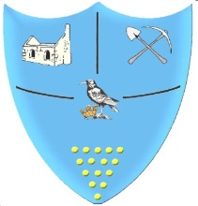 | Year 1- Spring 1- Homework Grid
 | Geography/History | Art/DT/Music | Science/Maths/ICT | R.E. / P.S.H.E/ PE
Past  Revisit | Make a fact file for Mary Anning. Why was she significant? | Use painting or drawing techniques to create pattern. Use Hundertwasser for inspiration. | What season are we in? Draw and label signs of the season that you have observed. | Have a go at throwing a small ball up in the air and catching it. How many times can you catch it without dropping it?
Present Consolidate | Draw a map of your local area. | Make up a song about Camborne. | How many different ways can you make 20? | Make a ‘sorry’ or a ‘thank you’ card for someone you know.
Future  Ignite | Find out about a significant king or queen from the past. | Design and make a 3D model of a castle. | Create a digital picture using an iPad or laptop. | Write and draw a picture of a goal you’d like to achieve in the future.
Bring your homework in to show in class or send a picture on eSchools.
Try to do at least one task each week.
If you would like to complete the Maths Whizz challenges at home, please us the login details which were sent home.
Don’t forget to also read at home and record this in your reading diaries.

