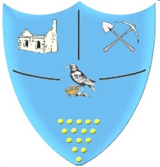 | Year 1- Autumn 2- Homework Grid
 | Geography/History | Art/DT/Music | Science/Maths/ICT | R.E. / P.S.H.E/ PE
Past  Revisit | Make your own map, make sure you include – The Equator, The North and South Poles. | Make a musical instrument. Have a go at playing it loudly/quietly and fast/slow. | Observe and keep a diary of the weather for the week. What do you notice? | Log in to Fitter Future and complete a workout.
Present Consolidate | What was life like in Victorian times? | Make a 3D model of a dinosaur. | Go on a walk, exploring your senses. Write/draw what you can hear, smell, touch, taste and see? | Retell the Nativity Story.
Future  Ignite | Draw a map of where you live. | Draw or paint a picture in the style of John Dyer. | Draw and label the parts of a plant. | Make a poster explaining how to stay safe online.
Bring your homework in to show in class.
Do at least one task each week.
Don’t forget to also read at home every day and collect 3 ruby red gems on Maths Whizz each week.

