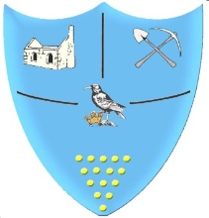 | Year 1- Autumn 1- Homework Grid
 | Geography/History | Art/DT | Science/Maths/ICT | R.E. / P.S.H.E/ PE
Past  Revisit | Draw a picture of your family and label it. | Design and make a pirate ship. | Draw an alien family. How many eyes are there altogether? | Balance on 1 leg. How long can you hold your balance?
Present Consolidate | Draw a map of the world. | Use a mirror to draw/paint a self-portrait. | What are the 4 seasons.  Draw a picture for each season. | Make your own story map of ‘The Creation Story’ and retell it to someone at home.
Future  Ignite | Who was Mary Anning? Research Mary Anning and write at least 3 facts about her. | Research different fossils. Look closely at some pictures of fossils and draw your own fossil. | Draw a picture of your favourite animal and label the different body parts. | Research ‘The Christmas Story’. Design a costume for one of the characters who would be in a nativity play.
Bring your homework in to show in class or send a picture on eschools.
Try to do at least one task each week.
Don’t forget to also read at home.

