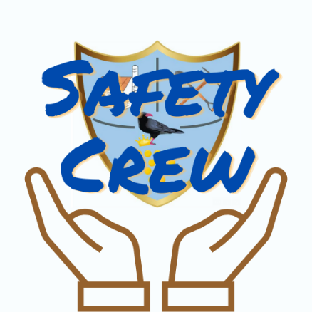

This week, the safety crew have worked hard to ensure ALL children know the importance of adults wearing the correct lanyard, in the Roskear School building. The Safety Crew has put together this simple table to teach you about the different types of lanyards we might see adults wearing. Please see the ‘Safety Crew’ section of our website to see the full informative videos.
Blue | 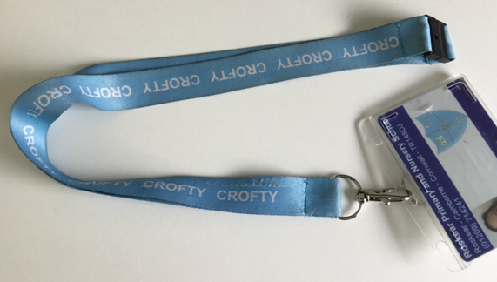 | This person is part of the Crofty family and safe to be in school.
Orange | 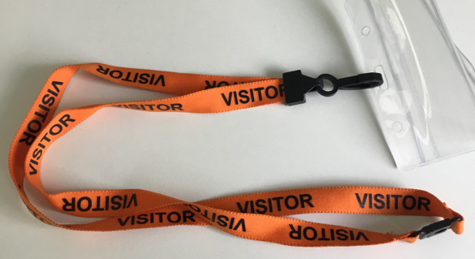 | This person is safe to be with children but not part of the Crofty family. They can be walking around school on their own.
Red | 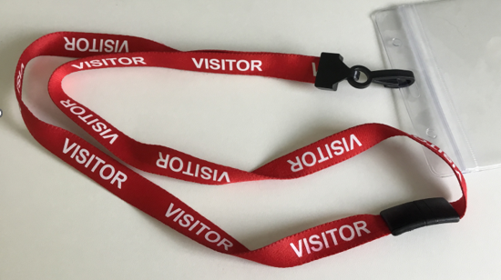 | They are not checked to be safe and are not part of the Crofty family. They need to be with someone with a blue lanyard on. If they are not, you need to tell an adult with a blue lanyard straight away.
No lanyard |  | If you see an adult with no lanyard on, you must tell an adult with a blue lanyard straight away. This does not have to be your teacher but can be any member of staff.

We know that this is to keep us safe.
The Safety Crew will be making sure that all children learn the difference between the coloured lanyards over the next few weeks and ALL children will be challenging any adult who is not wearing one.
Thank you to the Safety Crew for continuing to make sure we are all safe at school.

