**Reception Newsletter**

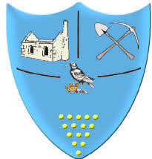

**Summer Term 2 2024**

This term we will be discovering what we know about the seaside and treasure. We will be learning about sea safety and will design our own boats, testing which floats the best and why that happened. The children will even design their own treasure maps!

In maths we will be using our developing knowledge and skills to solve simple addition and subtraction problems.

We are focusing on learning our number bonds up to 5, including double facts.



**Reminders**

Please note: If your child is absent you need to inform the school reception, this will help us to complete daily registers. Thank you.

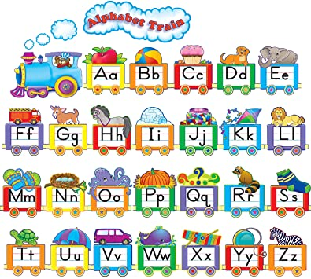

**We are looking forward to our final half term together in Reception. We want to say a personal thank you to all parents/carers for your continued support this academic year. The children have all made extraordinary progress and we are extremely proud of their positive attitudes to learning. We look forward to seeing how they can surprise us this final half term.**

**Your Reception Team.**

In RWI we will be continuing to blend and segment the sounds in words to help us with our reading and writing.

Remember reading books are changed every Monday, Wednesday and Friday.

**Polite reminder:** Children can choose one of the 35 books to read. Our library is full of great stories!

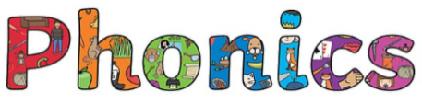

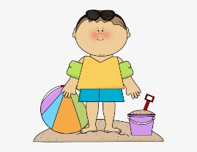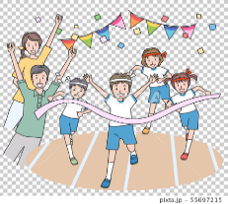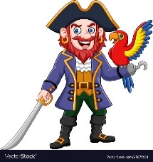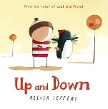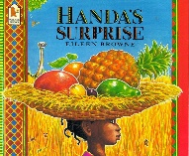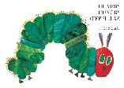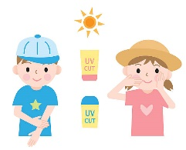

**Upcoming Dates**

**14th June** – Pirate dress up day

**Date TBC** – Beach trip (all day).

**2nd July** - Sports Day and picnic 11am–12pm.

**15th July** – Summer fayre afterschool

**23rd July** – Last day of school, 3.15pm finish.

**Sunhats and Sun cream**

If the weather is warm, please remember to send your child in with a sunhat

and labelled sun cream.

**Spare Clothes**

We would welcome any donations of spare

pants, socks and trousers.

**What can you find at the seaside?**

What would you like to buy in the beach café?

Can you memorise our ‘Talk for Writing’ stories and then retell them with actions?

Science  
 Can you design a boat that will float?

Can you design a treasure map?

What items are most valuable to you and why?

Let’s learn all about sea safety.

**Our new unit of learning this Summer term will be ‘What can you find at the Seaside’. These are the different themes we will be learning about.**



 Can you add

and subtract numbers

within 10?

