**Reception Newsletter**



**Keeping Informed**

Please check e-schools for any class updates.

All newsletters, events, term dates, lunch menus etc. are published on our school website and Facebook page.

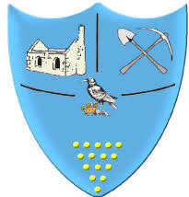

**Spring Term 2 2024**

This term we will be talking about things that undergo changes, such as people, buildings and animals. We are extremely excited to announce that we will watch and care for some hatching chicks and caterpillars who change into butterflies.

In maths we will be continuing to explore numbers to 10 and will be thinking of the different number bonds and patterns we can see to make our counting faster.



**Reminders**

Please note: If your child is absent you need to inform the school reception, this will help us to complete daily registers. Thank you.

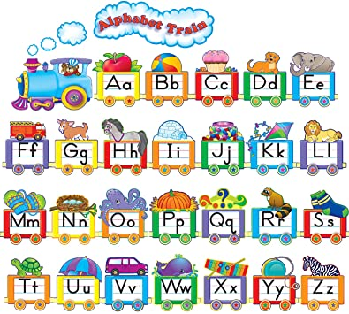

**We are looking forward to the next half term, thank you for your continued support. We will do all that we can to support you and your children and are always available to answer any questions or assist with any needs you may have.**

**Have you**

**changed?**

As we are looking at ‘changes’ we are asking for any photos of our class members growing. To see the ‘changes’ we would need a photo of them as a baby or a toddler for our ‘Guess Who?’ competition.

Please send in any photos, either through eSchools or originals, we will copy and hand the originals back to you as soon as possible.

In RWI we will be continuing to blend and segment the sounds in words to help us with our reading and writing. We are writing simple labels and sentences and have introduced red words. We cannot phonetically say these words so we just need to remember them.

Remember reading books are changed every Monday, Wednesday and Friday.

**Polite reminder:** Don’t forget to bring any ‘WOW moments’ you’ve

recorded at home!

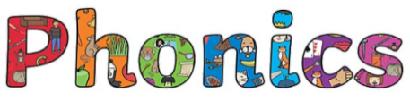

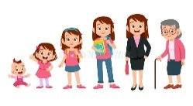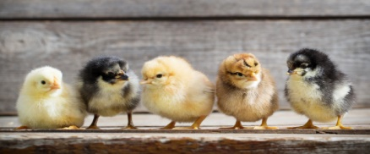

**Upcoming Dates**

19th February – school CLOSED for inset day.

We are having a fashion show - Date TBC.

7rd March - World book day: Story character dress up

8th March - Chocolate Bingo after-school.

The school will break up on Friday 29th March for the Easter Holidays.

**What changes in Springtime?**

‘First’, ‘Next’ and ‘Then’

How are chickens born?

What positional language do we know?

Science  
 Observations of growth and decay

Can you design a map?

What happens to a caterpillar?

Let’s have a fashion show.

**Our new unit of learning this Spring term will be ‘What changes in Springtime?’. These are the different themes we will be learning about.**

