Flowers and Growing!

Talk for Writing

The story of ‘The Very Hungry Caterpillar’ will be learnt by the children with actions.

Classroom flower shop

We will use real money to buy flowers. We will write and design bouquet orders.

We are going on a trip!

The children will be visiting Duchy College Rosewarne to visit the animals, beautiful gardens and plants.

Let’s Write

We will write sounds we can hear and will be developing our writing skills using full stops, finger spaces and capital letters. We will write labels, captions and simple sentences.

Can you recall ways to make 10?

Where does our food come from?

Learning about the importance of a healthy balanced diet.

Our new unit this Summer term will be ‘How does your garden grow?’ These are the different themes of learning that we will be focusing on.

We will be planting flowers and growing our own vegetables.





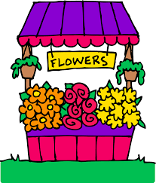

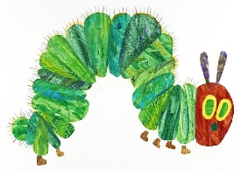

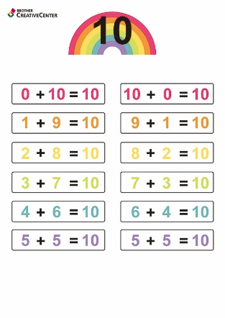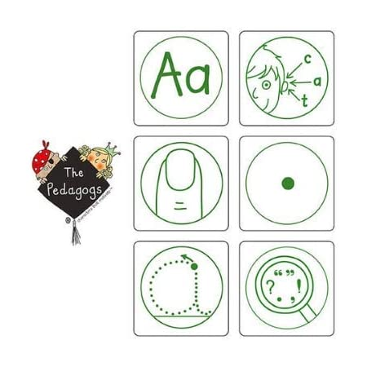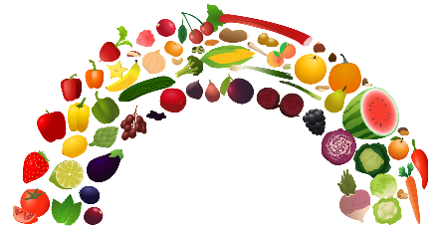

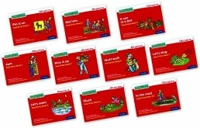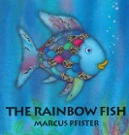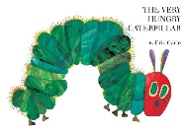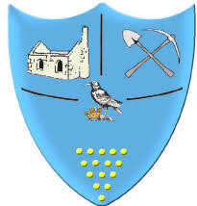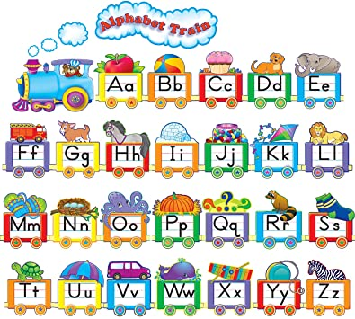

**35 BOOKS TO READ**

The children can choose a fabulous book to borrow from the class library and return it when they would like another one.

Please remember to bring your book bags for this. Reading books can be changed on a Monday, Wednesday and Friday.

**Reception Summer Term**

**Reminders**

Please note: If your child is absent you need to inform the school reception, this will help us to complete daily registers. Thank you.

**School Timings:**

Arrival for Reception is 8.40 – 8.50am with collection at 3.20pm. We please ask that parents/carers are prompt for collections.

**Important dates:**

6th May – School closed for Bank Holiday

Trip to Duchy Rosewarne TBC.

Visit to Camborne library TBC

Term ends Friday 24th May.

**Keeping Informed**

Please check e-schools regularly for any class updates.

All newsletters, events, term dates, lunch menus etc. are published on our school website or Facebook page.

**Summer Term 1 2024**

This half term we are learning about flowers and plants and what they need to grow. We will care for our flowers and plants each day. We will learn about ‘bees’ and know why they are so important to us. We will also be learning about how to maintain a healthy lifestyle. We are going to identify seasonal changes, including being ‘weather watchers’.

Chapel Porth staff:

Mrs Natasha Davies – Teacher

Miss Polly Pengelly – Teaching Assistant

Miss Isabella R-Hills – Teaching Assistant

Porthcurno staff:

Mrs Sarah Lagdon – Teacher & Deputy Head

Mrs Sam Staples – Teaching Practitioner

Mrs Natalia Cowell – Teaching Assistant

**We are pleased to welcome your children into their final term of Reception. We will do all that we can to support you and your children during this time and are always available to answer any questions or assist with any needs you may have. Thank you for your support.**