**Reception Newsletter**



**Keeping Informed**

Please check e-schools for any class updates.

All newsletters, events, term dates, lunch menus etc. are published on our school website or Facebook page.

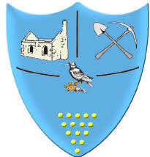

**Spring Term 1 2024**

This term we will be talking about things we might see in the sky, people who help us and Superheroes!

In maths we will be ordering and comparing different sizes. We will also be ordering numbers and learning about the value of them.



**Reminders**

Please note: If your child is absent you need to inform the school reception, this will help us to complete daily registers. Thank you.

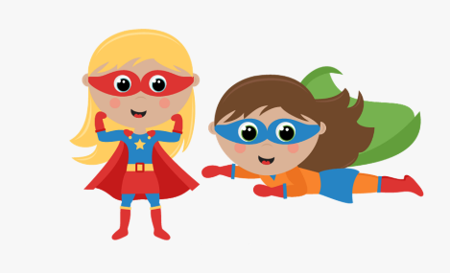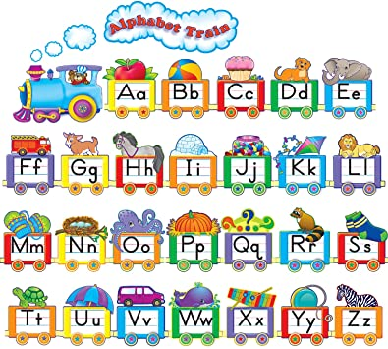

**We are looking forward to the next half term, thank you for your continued support. We will do all that we can to support you and your children and we are always available to answer any questions or assist with any needs you may have.**

**‘WOW’ moments**

Please continue to tell us about any ‘wow’ moments your child has at home. You can fill in one of our ‘Wow Stars’ and these are displayed on our ‘Wow Wall’. You can additionally contribute to your child’s learning by responding to learning experiences shared to you via eSchools.

If you have any queries about accessing eSchools please speak to a member of staff.



In RWI we will be continuing to blend and segment the sounds in words to help us with our reading and writing. We are working on writing simple sentences, simple CVC words and red words. Do not forget finger spaces!

Remember that reading books are changed every Monday, Wednesday and Friday.

Each time your child reads

at home, please sign their

reading record diary to

collect the Karate reading bands.

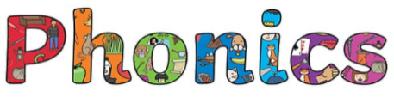

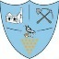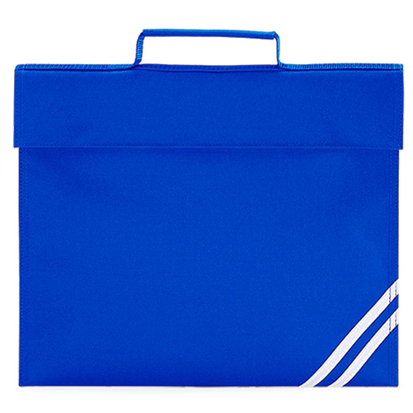

**Upcoming Dates**

We are having a Superhero and Princess dress up day on **Friday 12th January** to introduce our new unit of learning!

The school will break up on **Friday the 9th of February** for Half Term.

What can you see in the sky?

‘First’, ‘Next’ and ‘Then’

How does weather change?

Science  
 space & bubbles!

The Billy Goats gruff.

Someone  
bigger.

Let’s go fly  
a kite!

**Our new unit of learning this Spring term will be ‘What can you see in the sky?’. These are the different themes we will be learning about.**

Superheroes!

