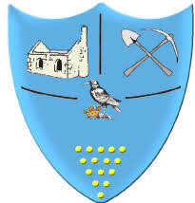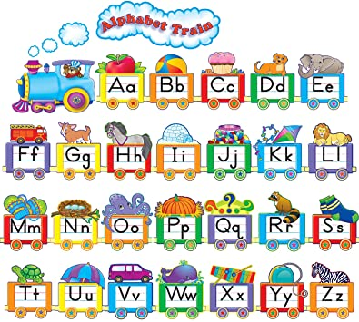

Chapel Porth staff:

Mrs Natasha Davies – Teacher

Miss Polly Pengelly – Teaching Assistant

**We will do all that we can to support you and your child(ren) during their first year at Roskear and we are always available to answer any questions or assist with any needs you may have. Thank you for your support.**

**Reception Newsletter**

**Autumn Term 2**

This half term we are learning about the farm and shopping. We are going to explore the farm, draw simple maps and find out about farm animals. We will be spending our pennies at the farm shop, where we can buy real fruit and vegetables.

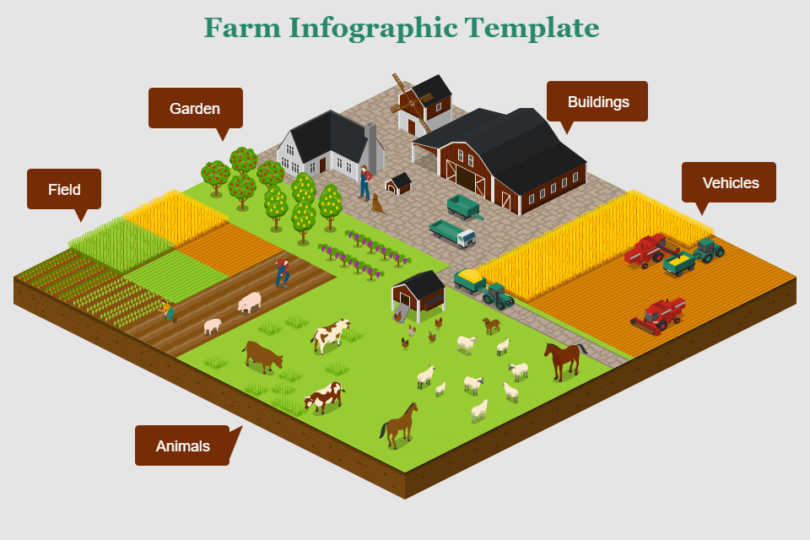

Porthcurno staff:

Mrs Sarah Lagdon – Teacher & Deputy Head

Mrs Sam Staples – Teaching Practitioner

Mrs Natalia Cowell – Teaching Assistant

**Keeping Informed**

Now it is getting colder, please make sure that your child always has a coat.

Please ensure that your child brings their book bags to school every day. They can change their reading books Monday, Wednesday and Friday.

**Reminders**

Please note: If your child is absent you need to inform the school reception, this will help us to complete daily registers. Thank you.

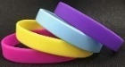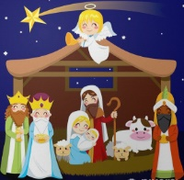

**Wow moments**

**Books to read**

We will be introducing our in class library this term where children can borrow stories to share at home.

In your book bags you will see wow labels – these are for you to share any new or wonderful home learning and developments! We would love to hear about them.

**Karate Reading bands**

Please remember to sign your reading record as we will be introducing reading bands this term. More information to follow.

.

**35**

**School Timings**

Arrival for Reception is 8.40 – 8.50am with collection at 3.20pm.

**Upcoming Dates**

Porthcurno parents meeting – 30.10.23

Chapel Porth parents meeting - 02.11.23

We are looking forward to the upcoming festive season including

our Christmas Nativity

performance – 8.12.23

What happens on the Farm?

Living on the farm.

Animals we might see at the farm.

Let’s use the map to get around the farm.

The very first Christmas story.

Let’s write  
a list.

Where does our food come from?

**Our new unit of learning for the second part of the Autumn term will be ‘What happens on the farm?’. You can help us by talking about the following points below at home.**

Setting up a farm shop

using real money.

