Nursery Newsletter
Summer Term 2 2024

Sand, Sea and Sunshine
Our unit of learning is called ‘Sand, sea and sunshine’ We will be learning about sea and beach wildlife. Please see the Nursery eSchools page for more details.

Fun in the sun
As usual we will be using our outdoor area every day during Nursery sessions. On sunny days please could you provide your child with a named hat. Thank you.
Permission slips for sun cream are ongoing

Remember: Please could you inform the school if your child is absent from Nursery. This will help us to complete our daily registers. Thank you.
Early Reading
This half term we will continue to play Phase 1 Letters and Sounds games. We will also be learning more initial sounds from our school phonics scheme, Read, Write Inc. Children will be learning sounds and matching them to objects. For further information check out the website.http://www.ruthmiskin.com/en/resources/parent-tutorial-1-understanding-read-write-inc-phonics/

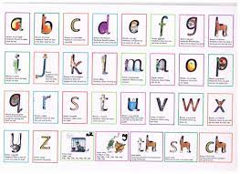

Independent Skills
Wow! We are SO impressed by the children who are learning to zip up coats, take off and put on jumpers, put shoes on, hang up their bags and coats. All of these skills will
help children settle into their reception classes and be ready to learn.

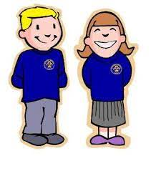

Maths Ideas
Keep counting! The children are counting beyond 10 and sometimes 20 now! Help them at home by pointing out numbers in the environment, sharing out biscuits, cutlery fairly, adding small amounts of e.g. pennies.
Also point out 2d and 3d shapes in the environment, measure water by pouring cups into a bucket, talk about heavy and light and tall and short.

Writing
Lots of children can now independently write their names. Some can copy letters and some are trying hard. Please can we ask that you keep going with name writing at home. It will really help your child in their new reception class.

Questions
If you have any questions about transition into reception, please ask a member of Nursery staff.

