Nursery Newsletter
Summer Term 1 2024

Once upon a time
Our new Unit of learning is ‘Once upon a time?’ We will be learning to recall stories and rhymes. We will base our learning around stories e.g. Goldilocks and the three Bears, Little Red Riding Hood and There Was a Princess Long Ago.
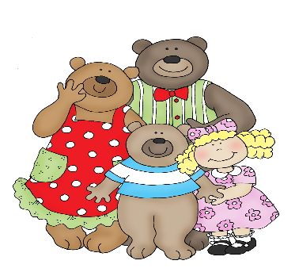

Fun in the sun
As usual, we will be using our outdoor area every day during Nursery sessions. On sunny days, please could you provide your child with a named hat. If necessary, sun cream should be applied before school. Thank you.

Remember: Please could you inform the school if your child is absent from Nursery. This will help us to complete our daily registers. Thank you.

Phonics

This half term we will be playing listening games e.g. What’s that noise? And ‘I spy’. If you play ‘I spy’ at home say ‘I spy with my little eye something beginning with e.g. ssssss’

Look out for letters that children know in books and say the sounds they make.
Read stories every day and ask children to join in, turn pages, point to words etc.
Read, Write, Inc.
We will be learning the picture cards and saying the sounds in our daily lessons.
Wow Moments
We enjoy hearing about all of your children’s achievements and celebrating your child’s special moments. From name writing to doing up zips and buttons. Please fill in a WOW moment for the display in the cloakroom.
Marvellous Maths
In maths this half term, we will be counting accurately, matching numerals to sets, weighing (heavy and light) and measuring using cubes. We will also be continuing with our favourite rhymes. See below.

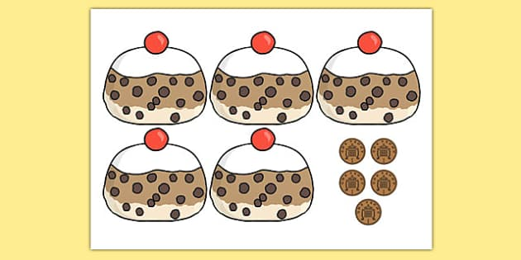

5 currant buns in a baker’s shop
Round and fat with a cherry on the top
Along came (child’s name) with a penny one day
Bought a currant bun and took it away.

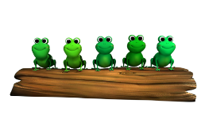
5 little speckled frogs
Sat on a speckled log
Eating some most delicious bugs
Yum! Yum!
1 jumped into the pool where it was nice and cool
Then there were 4 green speckled frogs
Glub! Glub!
Independence
In Nursery we are trying to help children prepare for their Reception classes in September.
You can help your child by teaching them to
- Put on and do up their coat.
- Remove socks and shoes and put them back on again.
- Recognise their names in their jumpers/cardigans/coats.
- Use the toilet on their own.
- Cut up their food and use a knife, fork and spoon.
- Change into shorts and tee-shirt for PE

