Nursery Newsletter
Autumn Term 2 2023

Let’s Go!
Our next Unit of Learning is called ‘How will we get there?’ We will be learning about different methods of transport. Sometimes we will base our learning around a story e.g. ‘The whales on the bus’ by Nick Sharratt and sometimes we will use songs and rhymes e.g. ‘Row, row, row your boat’

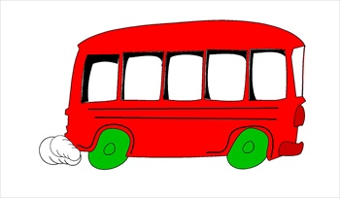

Remember: Please could you inform the school if your child is absent from Nursery. This will help us to complete our daily registers. Thank you.

Wow moments!

We enjoy hearing about all of your children’s achievements and celebrating your child’s special moments. Please let us know via eSchools or ask for a Wow moment slip.

Top tips for talking
Help your child use more words by adding to what they say. For example, if your child says ‘bus’ you say ‘big bus’. If your child is using two words, then you could use three words. For example, child says, ‘Dolly
breakfast’; adult says, ‘Yes, dolly is eating breakfast.’
If your child is using longer phrases and sentences try introducing new vocabulary. Children love learning words, the longer the better!

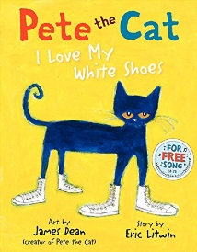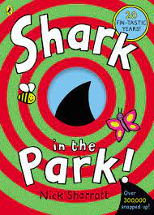
BOOKS!
Favourites in Nursery at the moment are:
Maisy mouse by Lucy Cousins
Shark in the park by Nick Sharratt
Pete the cat by Eric Litwin
The Whales on the Bus by Nick Sharratt
IDEAL CHRISTMAS PRESENTS!
Encourage your child to hold the book and turn the pages carefully. Ask them to tell the story with you. Talk about what might happen next.

Name writing
Please keep up the fantastic work with name writing at home and remember to encourage correct pencil grip.

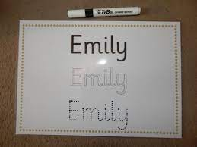

Names are written with a capital letter at the beginning and the rest lower case.

Borrow a Book!
Please encourage your child to borrow a book from the Nursery Lending library outside the door. We try to update the library as often as possible and there are some great books to share.
