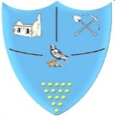Art and Design Overview
Learning: For a better future
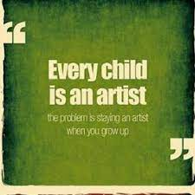
Art Rationale
Art in all its forms is broad and far-reaching and dates back to our earliest civilisations. It reflects societies and narrates history. The arts is one of the world's biggest employers and generates trillions of income and revenue to the UK economy, from fashion, to architects, to landscape garden designers to art exhibitions and galleries. It is important therefore, that pupils, through a study of past and present artists, develop an appreciation of the different genres and mediums.

Cornwall has for generations attracted a variety of artists to the county. Its beautiful and far-reaching coastlines have been an inspiration and subject for many. Pupils will encounter Barbara Hepworth’s work at her museum in St Ives along with some contrasting modern pieces of art at the Tate.

Intent
We engage, inspire and challenge by teaching pupils about a range of artists from different movements, ethnicity, gender and backgrounds, including those that reflect their own.
We provide knowledge and skills by offering a spiral curriculum that gives children an opportunity for experimentation, practice and expression. Where appropriate, we offer opportunities to link art with other subjects in order to deepen knowledge and understanding of particular skills, techniques, or stimuli.
We teach pupils to think critically by providing regular opportunities to reflect on artists’ work and their own using subject specific vocabulary. Teachers model metacognitive strategies which encourage pupils to do the same.
We teach pupils that art reflects and contributes to history and culture. Our curriculum both celebrates diversity and represents our community.

Each pupil has their own sketch book, which follows them through the school and provides concrete evidence of their skill development within and across key stages.

 | Nursery | Reception | Year 1 | Year 2 | Year 3 | Year 4 | Year 5 | Year 6
Autumn 1-  Looking after our planet | Nursery Rhymes | Friends and Family | What is Planet Earth? | Why do we need to look after our oceans? | What could survive the Sahara Desert? | Why are the rainforests important to our planet? | How is climate change impacting polar biomes? | Are we destroying our oceans?
 | Create closed shapes with continuous lines and begin to use these shapes to represent objects | Focus: Painting  Artist: Wassily Kandinsky  Artist Study: Abstract expressionist  Cultural Capital  Russian artist  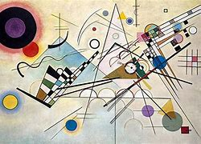  PSHE  Music | Focus: Drawing  Skills:  -Identify and discuss pattern  -Create pattern  -Extend the variety of drawing tools (pencil, oil pastels)  -Symmetry  Artist Study: Picasso- Cubism  Pablo Picasso 1881–1973 | Tate  Cultural Capital- Spanish artist  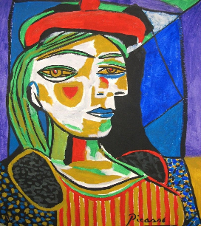  Geography  Maths | DT | DT | Focus: Painting  Skills:  -Use colour to reflect mood/feeling  -Introduce techniques to enable appropriate proportion  Artist Study: Henri Rousseau - Post-Impressionist Painter, Naïve Art  Henri Rousseau Paintings, Bio, Ideas | TheArtStory  Cultural Capital - French artist  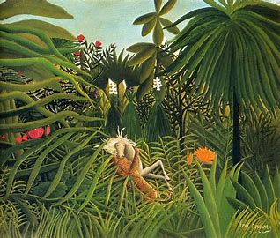  Geography  PSHE  Environment-Landscape/ seascape | Focus: Painting  Skills:  -Mix colour to express mood & divide foreground/background  -Effect of light on objects  Artist Study: Katsushika Hokusai - Landscape Artist  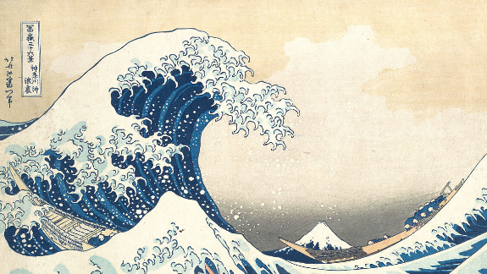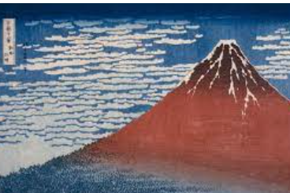Cultural Capital - Japanese artist  Geography  PSHE  Environment-Landscape/ seascape | DT
Autumn 2  Exploration and discovery | Let’s Go | At the Farm | How do we know that dinosaurs existed? | Who would you go exploring with? | How do we know that the Ancient Egyptians were an advanced society for their time? | If you were alive during this period in history, where would you rather live: Ancient Maya or Britain? | How have expeditions changed over time? | What effect did the Battle of Britain have upon the British people?
 | Create closed shapes with continuous lines and begin to use these shapes to represent objects | Focus: 3D  Artist: Nellie Nakamarra  Artist study: Pointillism  Cultural Capital -  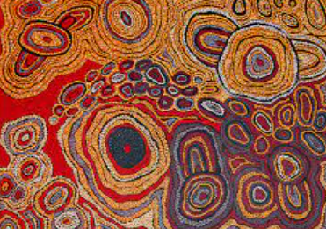  Australian, aboriginal artist. | Focus: 3D  Skills:  -Work with clay  -Develop impressed images  -Collage  -Make choices about suitable materials  Artist Study: Barbara Hepworth (Modernism, sculpture)  Barbara Hepworth Museum and Sculpture Garden | Tate  Cultural Capital-  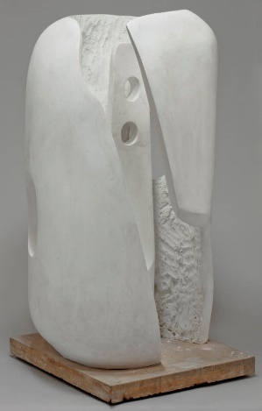  History  Maths  Science | DT | Focus: Painting  Skills:  -Create colour wheel  -Use different brush types  -Use different techniques  Artist Study:  Egyptian Art  Egyptian Art - Art for Kids! (weebly.com)  Cultural Capital-  Egyptian culture  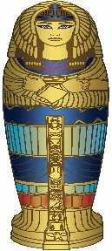  History  RE | DT | DT | Focus: Drawing  Skills:  -Use simple perspective in work  -Develop an awareness of composition, proportion and scale in their work  Artist study: Henry Moore shelter drawings- Sculptor  Who is Henry Moore? – Who Are They? | Tate Kids  Cultural Capital  British artist  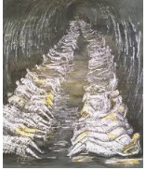  Science  History  Environment- Looking at past environments.
Spring 1 Counties Countries and continents | Going wild! | Up, Up and Away! | What is it like to live in Camborne? | Are all islands the same? | Why is London our capital? | Where would you rather live: Athens or London? | Why do people move across our continent? | How have economic activities impacted North America?
 | Draw with increasing complexity and detail, such as representing a face with a circle and including details. | Focus: Painting  Artist: Van Gogh  Artist study: Post-impressionist painter.  Cultural Capital  Dutch artist  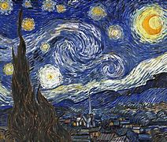 | DT | DT | DT | DT | DT | Focus: 3D  Skills:  -Experiment using layers and overlays to produce new colours and textures  -Incorporate the artists style into my design  Artist Study: Andy Warhol  Roy Lichtenstein- Pop Art Movement  Andy Warhol 1928–1987 | Tate  Cultural Capital  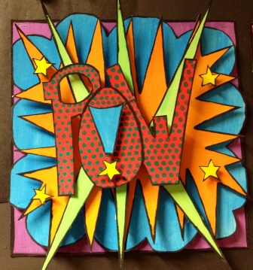  American artist  Geography  DT  Maths  Change- How Andy Warhol changed the way people perceived art, how you can take everyday objects and create art from them.
Spring 2  Marvelous Men and women | Ready Steady grow | Changes | Who was the better monarch? | Was the building of the Titanic a good idea? | Which era would you rather live in: Bronze Age, Stone Age or Iron Age? | Would you prefer to live as an Ancient Maya child or an Ancient Greek child? | Did Britain improve after the Romans left? | What were the events that led to slavery and eventually its abolition?
 | Use drawing to represent ideas like movement or loud noises | Focus: 3D  Artist: Andy Goldsworthy  Artist study: Sculptor and photographer  Cultural Capital  British artist  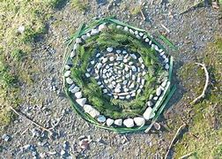 | DT | Focus: Drawing  Skills:  - Experiment with tools and surfaces (chalk on concrete, oil pastel on paper)  -Experiment with tone to create light and dark  Artist Study: Ralph Curnow (Marine artist, he spent 11 years on crew of Penlee lifeboat)  Focus to be on ’waves’  Ralph Curnow - Arts and Crafts In Cornwall (artistsincornwall.com)  The Penlee Lifeboat Disaster - Easymalc's Wanderings  Cultural Capital  Local artist  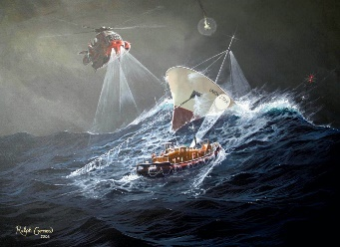  History  Geography  Environment- Landscape/ seascape/local artist | DT | Focus: Drawing  Skills:  - Work with precision and attention to detail  -Use an artistic style to influence drawing  -Geometric pattern  -Tea bag paper for final piece  Artist Study:Ancient Greek Vases- Pottery  Greek Vases - Art P.R.E.P. (weebly.com)  Cultural Capital  Ancient Greek culture  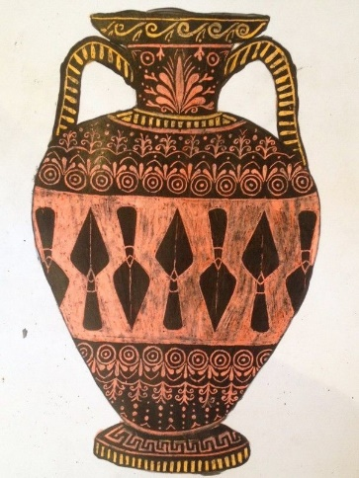  History  Maths | Focus: Drawing  Skills:  -Use different techniques to replicate texture on a surface  -Draw familiar objects with correct proportions  Artist: Saxon Art Study:Bayeux Tapestry  The Bayeux Tapestry - KS2 History - BBC Bitesize  Cultural Capital-  French  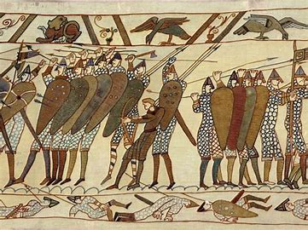  (children’s final pieces joined together on long roll of paper to create a ‘tapestry’)  History  Maths | Focus: Painting  Skills:  -Apply previous paint and colour learning to create chosen effect  -Explore mixed media to convey a message  Artist Study: ‘Sweet Clara and the Freedom Quilt’ by Deborah Hopkinson (Book)  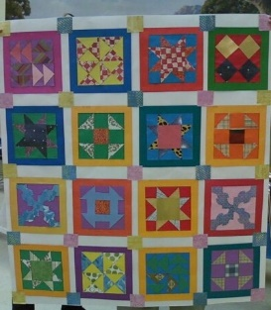  (Final tiles join together to make ‘Freedom Quilt’)  FreedomQuiltPatterns.pdf (crayolateachers.ca)  History  PSHE  Maths  Environment-Supports learning of North America
Summer 1  Active planet | Once upon a time | Plants and Flowers | How does the weather change? | Does it snow in Africa? | Are all forests the same? | What are the vital roles of rivers? | Why do people live near volcanoes? | Why is the aquatic biome important to Cornwall?
 | Show different emotions in their drawings and paintings, like happiness, sadness, fear, etc | Focus: Drawing  Artist: Claude Monet  Artist Study: Impressionist painter  Cultural Capital  French artist  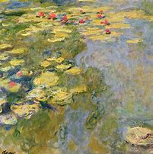  Environment-Landscape/ seascape | DT | Focus: Painting  Skills:  -Discuss regular and irregular pattern  -Make many tones of colour  -Develop ideas  Artist Study:  Tingatinga Art (African Culture)  https://wibseyprimary.co.uk/wp-content/uploads/2020/05/TINGATINGA-ART-PPT.pdf  Cultural Capital  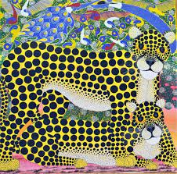  African culture  Geography  Maths | Focus: Drawing  Skills:  -Make different tones using graded pencils  -Awareness of perspective  -Choose from different mediums to achieve desired effect (pencil, charcoal, pastel)  Artist Study:  Ivan Shishkin- Landscape Artist  Ivan Shishkin - 522 artworks - painting (wikiart.org)  Cultural Capital  Russian artist  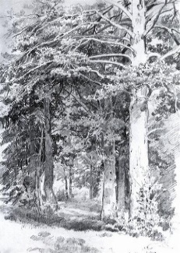  Geography  Environment-Landscape/ seascape | Focus: 3D  Skills:  -Plan and develop ideas  -Choose materials for the effect they create  -Add pattern and texture to 3D form  Artist Study:Guiseppe Arcimboldo  Mannerist artist  (Beach Clean)  High Quality Reproductions Of Giuseppe Arcimboldo paintings (giuseppe-arcimboldo.org)  Cultural Capital  Italian artist  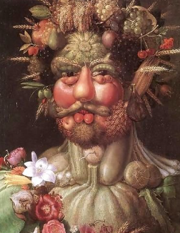  Science  Geography  PSHE  DT  Change- Environmental artist- Taking found objects (things that you find on the beach) to create an image with an environmental message. | DT | DT
Summer 2  Changing Britain | Here comes the sun | At the Seaside | Would you rather visit the seaside during Victorian times or today? | Was Sir Francis Drake a hero or a villain? | What did the Romans do for us? | What might Cornish life look like without Richard Trevithick’s inventions? | Who were the Vikings? | What impact did mining have on Cornwall and how did the closing of the mines impact upon the area?
 | Explore colour and colour mixing | Focus: Drawing  Artist: Kurt Jackson  Artist Study: Landscape  Cultural Capital  Local artist  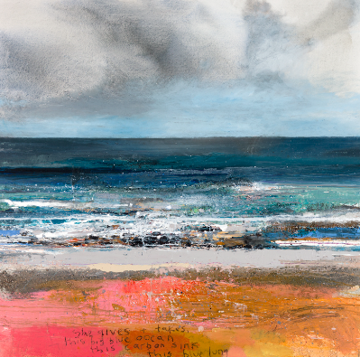  Environment-Landscape/ seascape/ local artist | Focus: Painting  Skills:  -Mix colours to create secondary colours  -Apply colour with range of tools  Artist Study: John Dyer  Contemporary artist  Artist John Dyer | The Art of John Dyer. British Artist working from Cornwall  Cultural Capital  Local artist  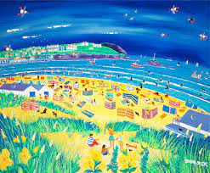  History  Environment-Landscape/ seascape/ local artist | Focus: 3D  Skills:- Use decorative techniques, patterns and textures in 3D  -Experiment by arranging, repeating, overlapping to create pattern  -Flower pressing  Artist Study:  Susan Fowler Gallery of Fine Art - Penzanace, Cornwall.  Cultural Capital  Local artist  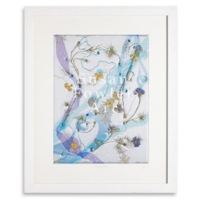  Science  History  Environment- local artist | Focus: 3D  Skills:  -Produce clay work using pinch, slab, coil techniques  -Explore carving as a form of 3D art  Artist Study:  Roman Pottery  #MetKids—How to Make a Clay Pot: Coil and Pinch - Bing video  Cultural Capital  Roman culture  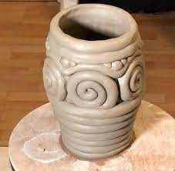  History  Maths | DT | Focus: 3D  Skills:  -Exploration of paper sculpture (folding, tearing, coiling, curling)  -Plan and develop ideas  Artist Study: Asya Kozina- Contemporary paper sculptures.  Asya Kozina — Artist (asyakozina-art.com)  How to make a paper Viking helmet | Best origami paper samurai helmet | Easy Paper Origami for kids - YouTube  Cultural Capital  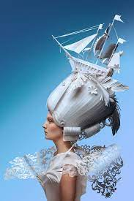  Russian artist  History  DT | DT

